- Assignment No. 3

- Name: Noman Ahmad
- Class (sec): BCSE (5C)
- Reg. No. : 147
Step by step analysis of Auto Rental Company……
Customer
- Customer can log in to the system
- Customer can be register
- Customer will search for car
- Customer can select car
- Customer will pay bill payment

Employee
- Employee can log in to the system
- Employee will maintain car information
- Employee can view rental reports
- Employee will generate bill for customer

Manager
- Manager can view rental reports
- It checks for maintenance
- Use case diagram
A

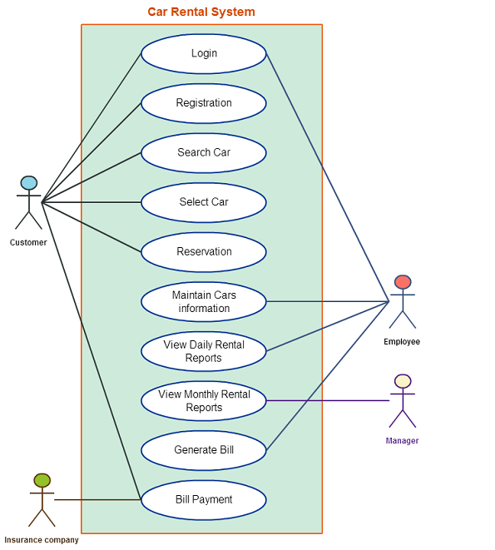

- Assignment no 4 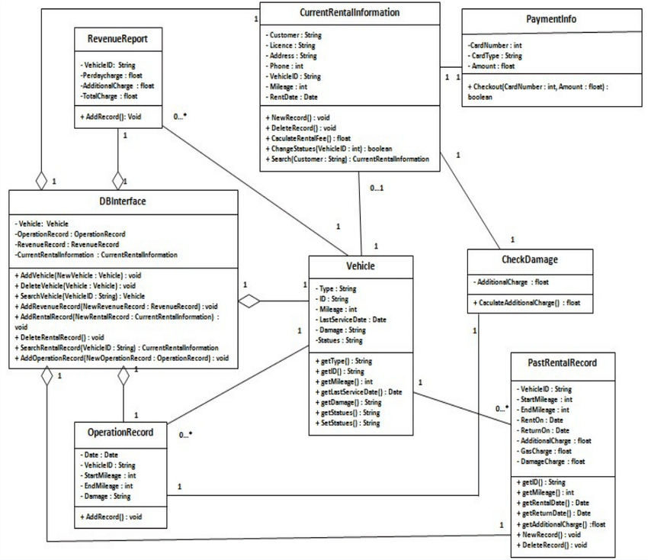
Class diagram

